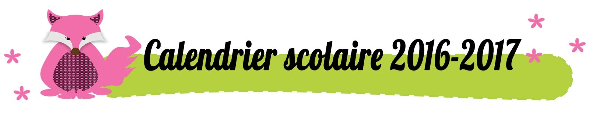
Août | Septembre | Octobre
L1 Fête Nationale CH | J1 | S1
M2 | V2 | D2
M3 | S3 | L3 Congé d’automne
J4 | D4 | M4
V5 | L5 | M5
S6 | M6 | J6
D7 | M7 | V7
L8 | J8 | S8
M9 | V9 | D9
M10 | S10 | L10
J11 | D11 | M11
V12 | L12 | M12
S13 | M13 | J13
D14 | M14 | V14
L15 Assomption | J15 | S15
M16 | V16 | D16
M17 | S17 | L17
J18 | D18 | M18
V19 | L19 | M19
S20 | M20 | J20
D21 | M21 | V21
L22 | J22 | S22
M23 | V23 | D23
M24 | S24 | L24
J25 | D25 | M25
V26 | L26 | M26
S27 | M27 | J27
D28 | M28 | V28
L29 | J29 | S29
M30 | V30 | D30
M31 |  | L31

Novembre | Décembre | Janvier
M1 Toussaint | J1 | D1
M2 | V2 | L2
J3 | S3 | M3
V4 | D4 | M4
S5 | L5 | J5
D6 | M6 | V6
L7 | M7 | S7
M8 | J8 | D8
M9 | V9 | L9
J10 | S10 | M10
V11 Armistice | D11 | M11
S12 | L12 | J12
D13 | M13 | V13
L14 | M14 | S14
M15 | J15 | D15
M16 | V16 | L16
J17 | S17 | M17
V18 | D18 | M18
S19 | L19 | J19
D20 | M20 | V20
L21 | M21 | S21
M22 | J22 | D22
M23 | V23 | L23
J24 | S24 | M24
V25 | D25 | M25
S26 | L26 Congé de Noël | J26
D27 | M27 | V27
L28 | M28 | S28
M29 | J29 | D29
M30 | V30 | L30
 | S31 | M31

Février | Mars | Avril
M1 | M1 Mercredi des Cendres | S1
J2 | J2 | D2
V3 | V3 | L3 Vacances de Pâques
S4 | S4 | M4
D5 | D5 | M5
L6 | L6 | J6
M7 | M7 | V7
M8 | M8 | S8
J9 | J9 | D9
V10 | V10 | L10
S11 | S11 | M11
D12 | D12 | M12
L13 Vacances blanches | L13 | J13
M14 | M14 | V14
M15 | M15 | S15
J16 | J16 | D16 Pâques
V17 | V17 | L17
S18 | S18 | M18
D19 | D19 | M19
L20 | L20 | J20
M21 | M21 | V21
M22 | M22 | S22
J23 | J23 | D23
V24 | V24 | L24
S25 | S25 | M25
D26 | D26 | M26
L27 | L27 | J27
M28 Mardi Gras | M28 | V28
 | M29 | S29
 | J30 | D30
 | V31

Mai | Juin | Juillet
L1 Fête du Travail | J1 | S1
M2 | V2 | D2
M3 | S3 | L3 Vacances d’été
J4 | D4 | M4 Reprise le
V5 | L5 Pentecôte | M5 21.08.17
S6 | M6 | J6
D7 | M7 | V7
L8 | J8 | S8
M9 | V9 | D9
M10 | S10 | L10
J11 | D11 | M11
V12 | L12 | M12
S13 | M13 | J13
D14 | M14 | V14
L15 | J15 Fête-Dieu | S15
M16 | V16 | D16
M17 | S17 | L17
J18 | D18 | M18
V19 | L19 | M19
S20 | M20 | J20
D21 | M21 | V21
L22 | J22 | S22
M23 | V23 Indépendance Jura | D23
M24 | S24 | L24
J25 Ascension | D25 | M25
V26 | L26 | M26
S27 | M27 | J27
D28 | M28 | V28
L29 | J29 | S29
M30 | V30 | D30
M31 |  | L31

